**COMSATS UNIVERSITY ISLAMABAD**

**ATTOCK CAMPUS**

**Department of Computer Science**

**Assignment No:** 01

**Course Name:** DS-LAB

**Program:** BCS**-**4



**Submitted to: Mam Anum Moin**

**Submitted by :**

|  |  |
| --- | --- |
| **Abdul Basit** | **SP24-BCS-033** |

**Date of submission: September 15, 2025**

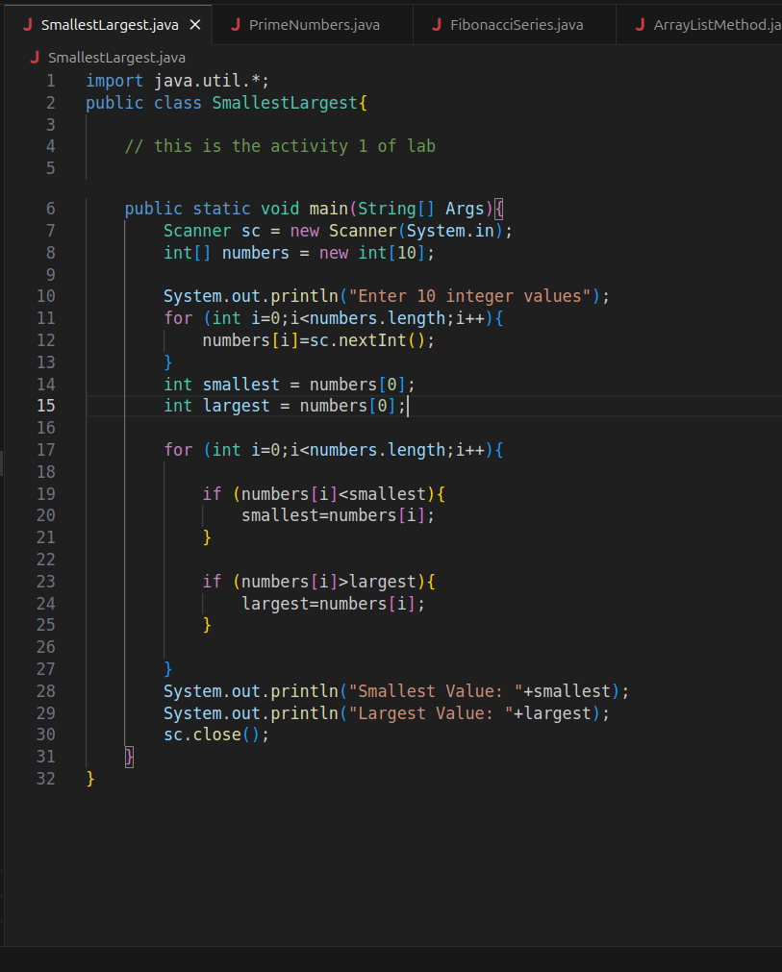**1) Write a program that prompts the user to enter ten integer values. The program stores the values in an array, finds and displays the smallest and largest values in the array.**

**2) Write a program that stores all prime numbers from 100 to 500 in array.**

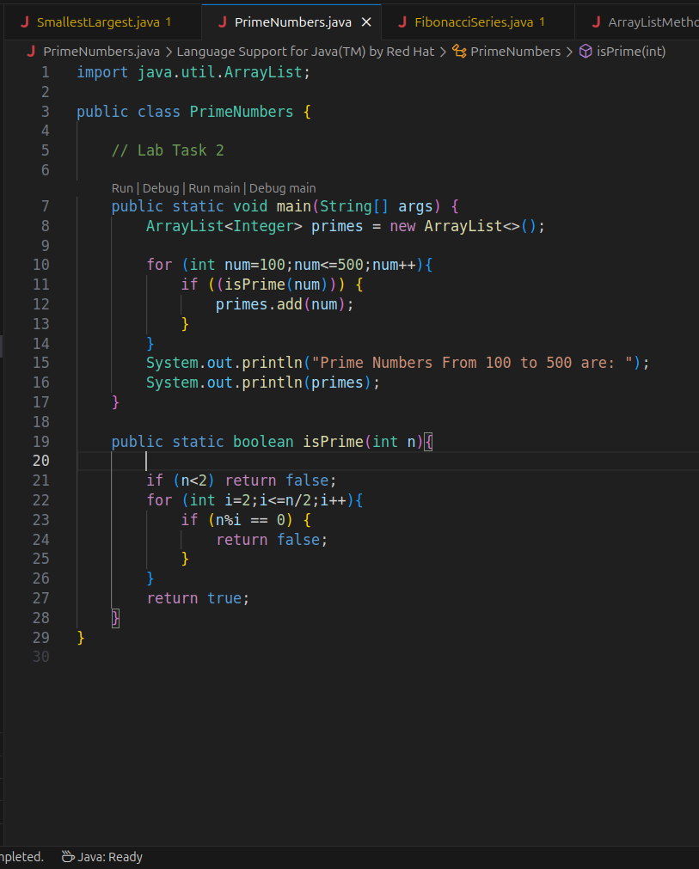

**3) Write a program that asks the user to enter a number and generate Fibonacci Series like given below using loop up to given number and stores the results in an array. If user enter number = 20, your output must be 0 1 1 2 3 5 8 13 21 34 55 89 144 233 377 610 987 1597**

**2584 4181. Your program then displays the values stored in the array.**

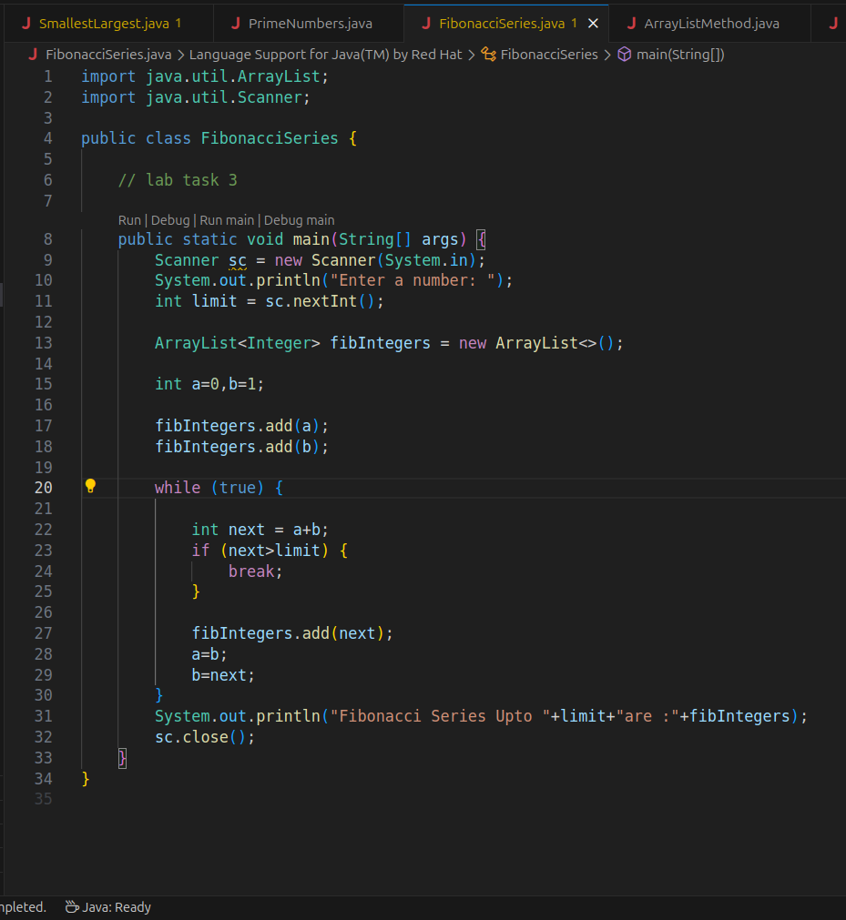

**4) Write a program that uses at least five methods of the ArrayList.**

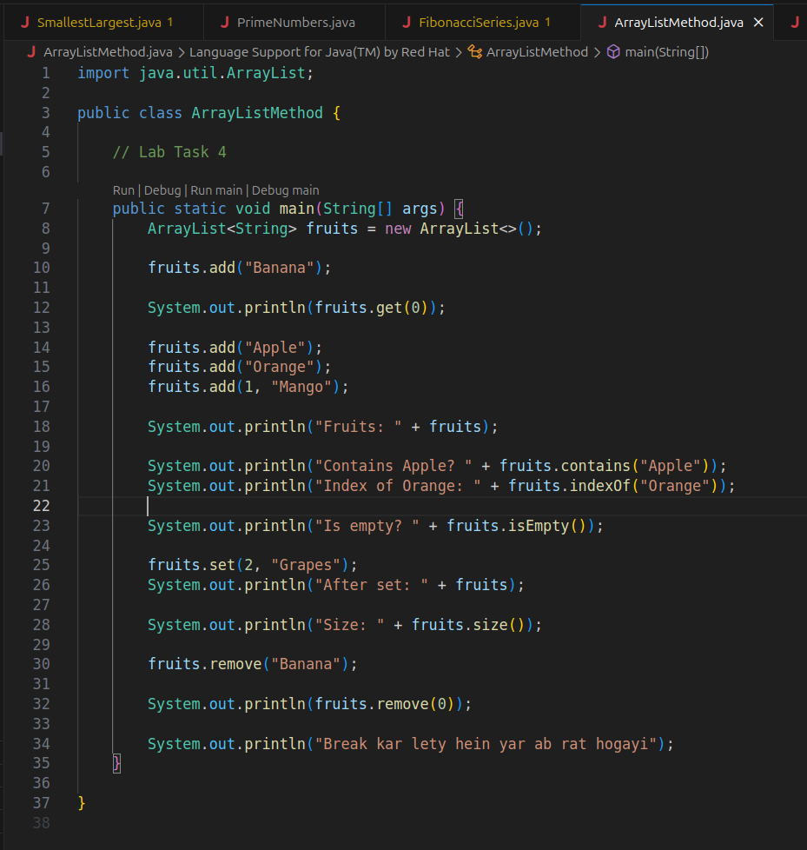

**5) Write a program that tells whether two consecutive elements of the array are same/duplicates. The program prints the positions and the value.**

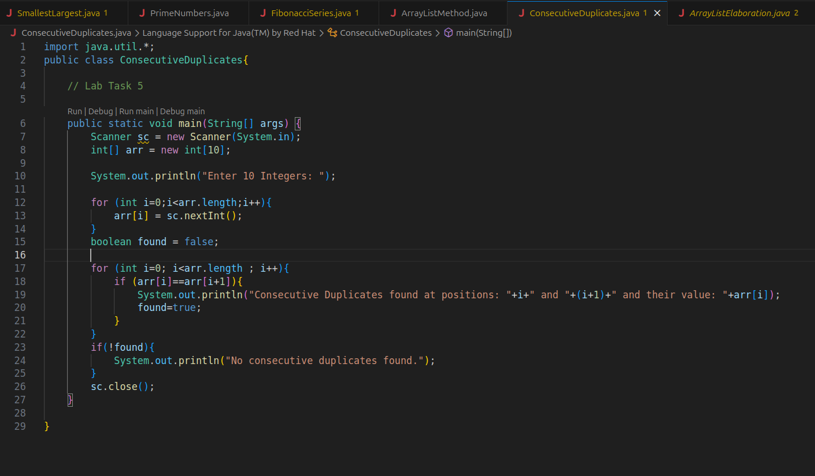

**6) Write a program that prints duplicates (if any) of each element of the array.**

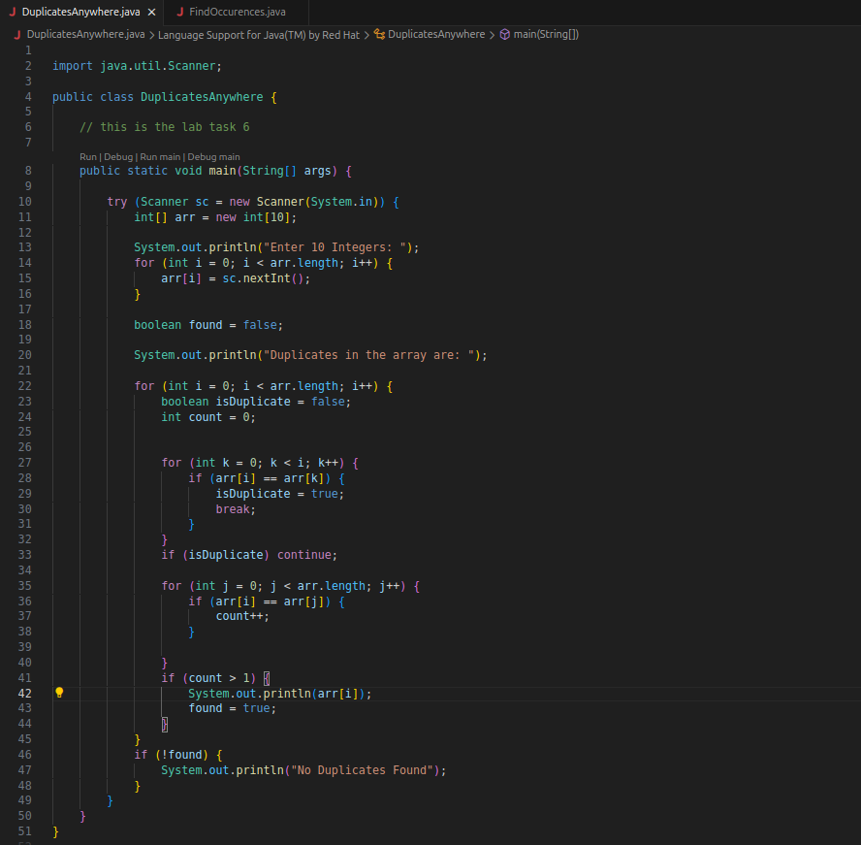

**7) Write a program that asks the user to enter ten values and stores the values in an array. The**

**program then asks the user to enter a value and finds all occurrences of the value i.e., prints**

**index numbers. Prints not found if the no occurrence is found.**

